

FULLERTON HEALTHCARE GROUP PTE LTD

User Manual Documentation

SMS Notification

User Manual
After login to SAP B1, click on the launch application icon highlighted in the below mock screen.

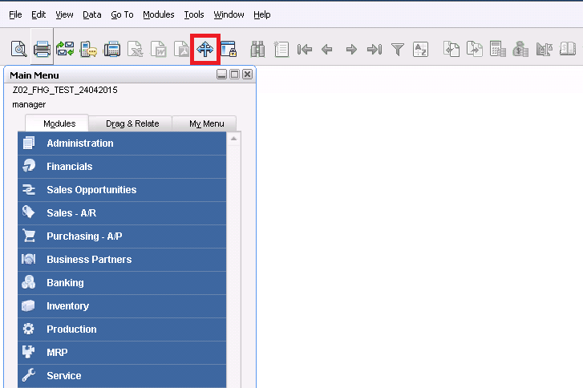

Once clicked, the launch application window will prompt and it will displays a list of application to trigger.
In this we can find the application name called “SMS Notification”, select that one once selected it will highlighted in orange color than click the button ”Run” in the bottom of the form. Find the reference image below for your easy start.

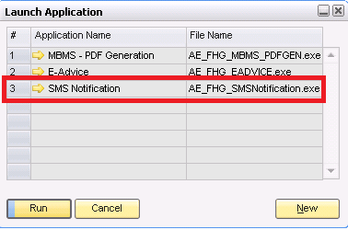

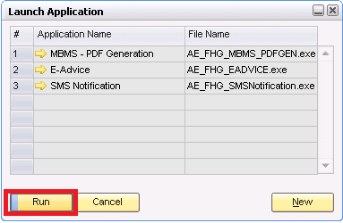

It opens the SMS Notification window for sending the SMS to client. Here we have to provide the Batch No. & Payment Type, based on those information this application will fetch the mobile no. & amount from the outgoing payments and triggers the SMS notification. The below mock screen will represent the way to trigger.

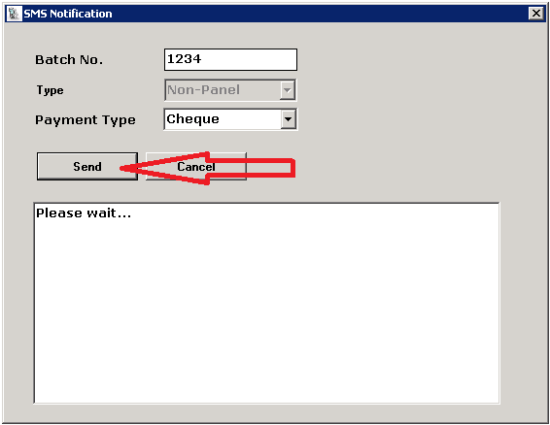

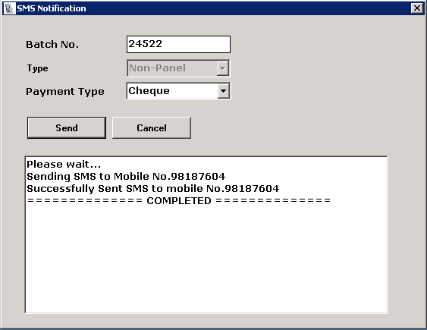

If no hindrance you will get the successful message in the white box, like the above screen and this application will change the field “Sent SMS” to “Yes”, so it will not trigger again for this document.

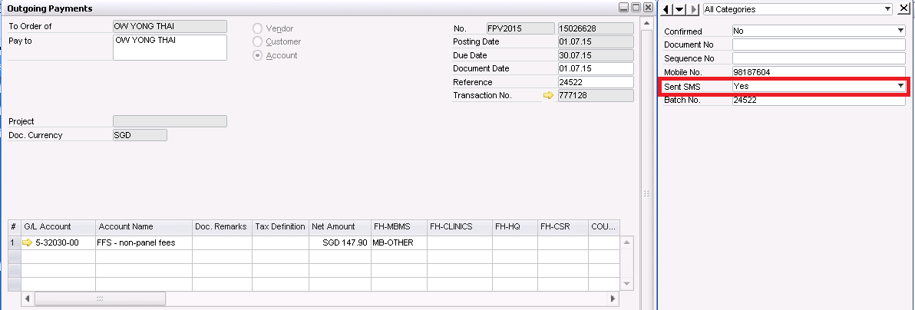

Validations

Some validation msg will be prompt if it fails before triggering the SMS.

Validation 1: (Batch No. field is empty)

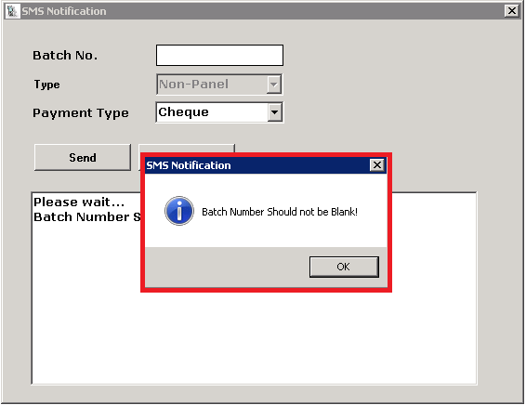

Validation 2: (Batch No. does not exists in SAP B1)

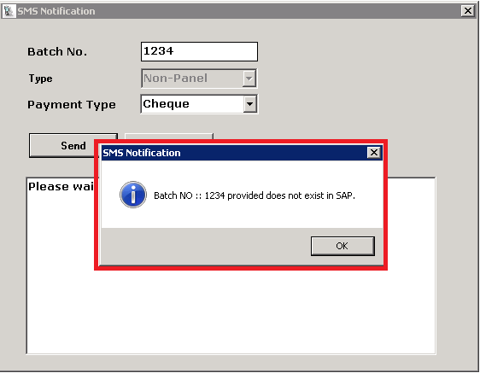

Validation 3: (No records found in SAP for SMS trigger)

If batch no. exists and no records found in SAP for particular batch and selected payment type then the following message will popup.
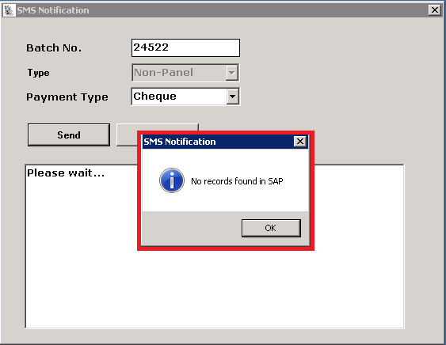

Validation 4:
If records are there but phone numbers are missing it will prompt the below validation msg, you can click “Yes” to trigger the SMS notification or (“No” or “Cancel”) for terminate the process.

